# Python Coding Task

Time: 30 Minutes

Level: Intermediate

## Q1. Understanding Access Specifiers

Create a class `Student` with the following properties:  
  
Class Requirements:  
1. `name` → Public attribute   
2. `_roll_number` → Protected attribute   
3. `__marks` → Private attribute   
  
Implement the following methods:  
- Constructor to initialize all attributes.  
- `display_details()` → Public method to display all attribute values.  
- `_update_roll_number(new_roll)` → Protected method to update roll number.  
- `__update_marks(new_marks)` → Private method to update marks.  
- `access_private_method(new_marks)` → Public method that uses the private method `__update_marks`.

**SOLUTION**

class Student:

    def __init__(self, name, roll_number, marks):

        self.name = name

        self._roll_number = roll_number

        self.__marks = marks

    def display_details(self):

        print("\n[Q1] Student Details:")

        print(f"Name: {self.name}")

        print(f"Roll Number: {self._roll_number}")

        print(f"Marks: {self.__marks}")

    def _update_roll_number(self, new_roll):

        self._roll_number = new_roll

  def __update_marks(self, new_marks):

        self.__marks = new_marks

    def access_private_method(self, new_marks):

  self.__update_marks(new_marks)

student = Student("Alice", 101, 92)

student.display_details()

**OUTPUT**

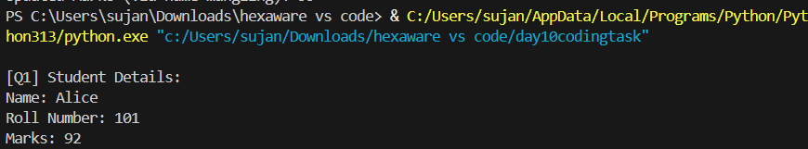

## Q2. Demonstrate Access

In the main section:  
- Create an object of the `Student` class.  
- Modify and print the `name` directly.  
- Modify and print the `_roll_number` directly.  
- Try accessing `__marks` directly and observe the result.

**SOLUTION**

print("\n[Q2] Demonstrating Access to Attributes")

student.name = "Alicia"

print("Updated Name (Public):", student.name)

student._roll_number = 202

print("Updated Roll Number (Protected):", student._roll_number)

try:

    print("Accessing Marks (Private):", student.__marks)

except AttributeError:

    print("Cannot access __marks directly → AttributeError")

**OUTPUT**

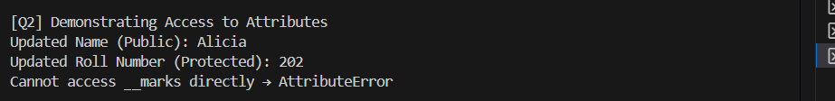

## Q3. Inheritance and Access Control

Create a subclass `Topper` that inherits from `Student` and includes:  
- A method `try_access()` that attempts to access `_roll_number` and `__marks` from the subclass.  
- Show what works and what doesn't.

**SOLUTION**

class Topper(Student):

    def try_access(self):

        print("\n[Q3] Accessing Members from Subclass:")

        print("Accessing _roll_number (Protected) from subclass:", self._roll_number)

        try:

            print("Accessing __marks (Private) from subclass:", self.__marks)  # Will raise error

        except AttributeError:

            print("Cannot access __marks directly from subclass → AttributeError")

topper = Topper("Bob", 303, 97)

topper.try_access()

**OUTPUT**

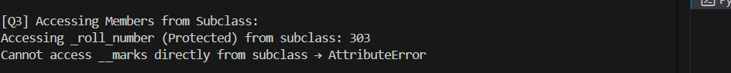

## Q4. Use of Name Mangling

Demonstrate how to access the private attribute `__marks` using name mangling technique from outside the class.

**SOLUTION**

print("\n[Q4] Accessing Private Attribute Using Name Mangling:")

print("Original Marks (via name mangling):", student._Student__marks)

student._Student__marks = 99

print("Updated Marks (via name mangling):", student._Student__marks)

**OUTPUT**

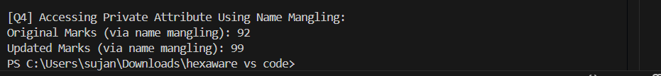

## Q5. Reflection

**Answer the following short questions:  
1. Why can’t private members be accessed directly?**

In Python, **private members** are defined with **double underscores** (e.g., __marks). This signals that these members are **meant to be hidden** from outside access and only used within the class itself.

Python uses a feature called **name mangling**, where:

self.__marks is internally renamed to: self._ClassName__marks → self._Student__marks

So, even though Python **does not have strict access control** like Java or C++, this mechanism:

* Helps **prevent accidental modification**
* Encourages **encapsulation** (hiding internal data)

**2. What is the purpose of using protected members in class design?**

Protected members are indicated by a single underscore (e.g., _roll_number). This is a convention, not a strict rule, to inform developers that the attribute is intended for use only within the class and its subclasses.

Protected members:

* Help maintain a clean interface for the class
* Allow subclasses to access certain internal attributes or methods
* Avoid unnecessary exposure of internal implementation to external code

They strike a balance between encapsulation and flexibility, especially in inheritance-based designs.

**3. How does name mangling help with private members in Python?**

Name mangling is Python's way of internally changing the names of private attributes to prevent accidental access. For example:

self.__marks is changed to:

self._Student__marks

This approach:

* Makes it harder for external code to accidentally access private members
* Prevents name clashes in subclasses
* Encourages the use of public methods to interact with private data

Name mangling does not make attributes completely inaccessible but helps enforce better design and encapsulation practices.